WAS - Tivoli Performance Viewer (TPV)

Jerry Cheng

[cheng1@us.ibm.com](mailto:cheng1@us.ibm.com)

# Introduction

Tivoli® Performance Viewer enables administrators and programmers to monitor the overall health of WebSphere® Application Server from within the administrative console.

This document explains the following topics:

* Enabling PMI and Starting TPV Logging
* Collecting TPV Log

# Enabling PMI and Starting TPV Logging

1. Select “**Performance Monitoring Infrastructure (PMI)**” from the left side menu, then select the target server you want to enable PMI from right panel. For example, after clicking the “**Performance Monitoring Infrastructure (PMI)**”, you can see a list of servers shown in right panel. You can click on the target server, e.g. **sampleServer1**, from the right panel, to see the PMI configuration for the target server.

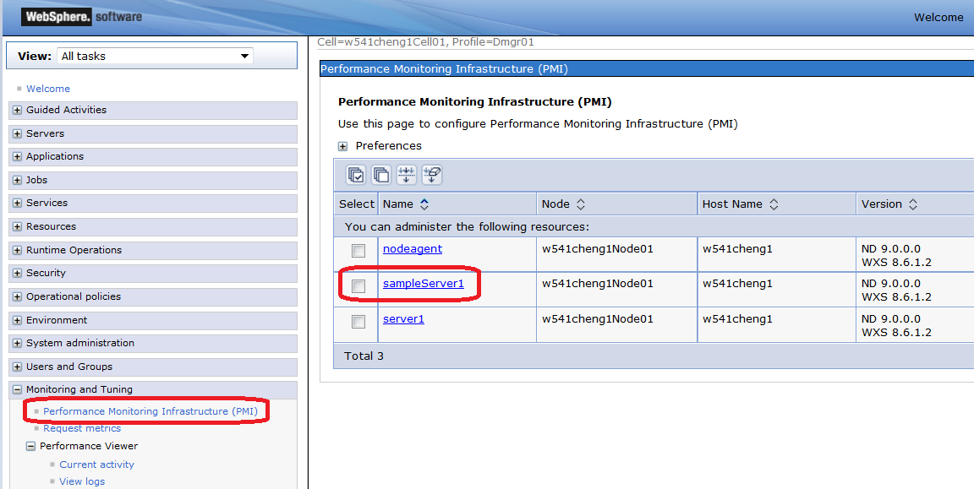

1. Ensure the “**Enable Performance Monitoring Infrastructure**” is checked, and click the “**Extended**”, then click “**OK**”.

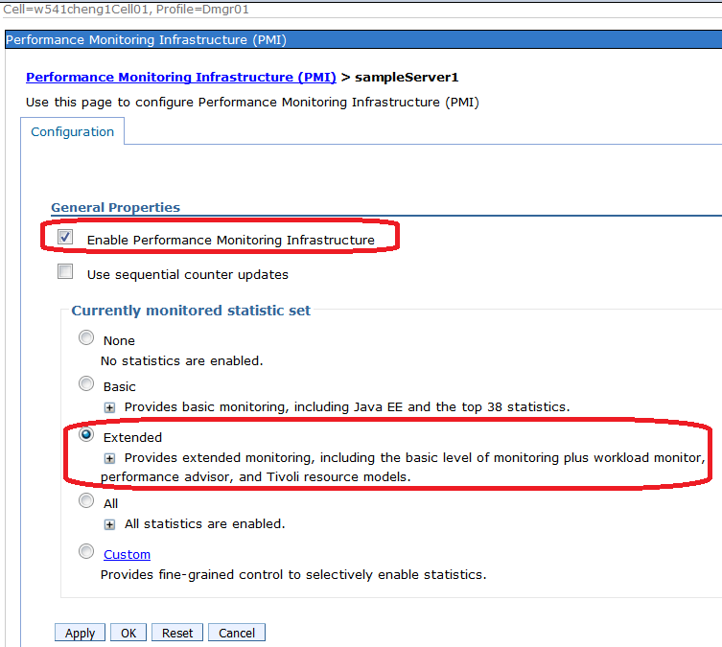

1. Click the “**Save**” on the following Message.

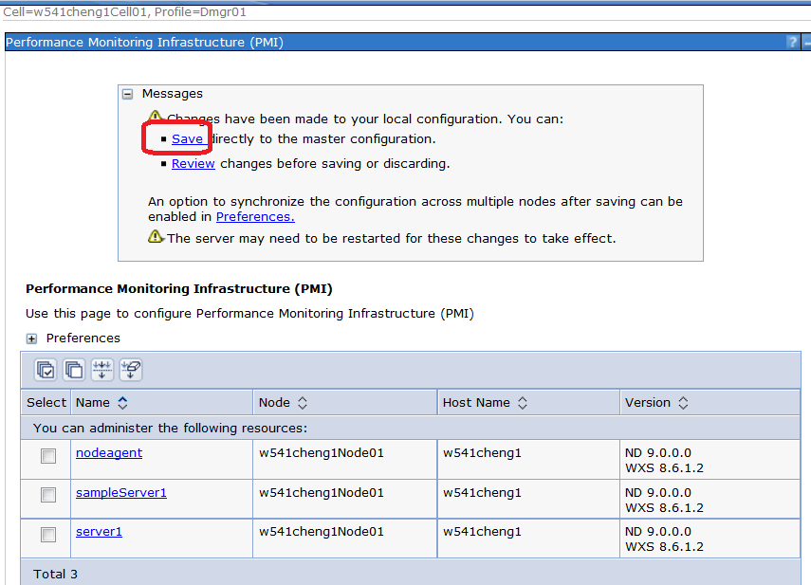

1. Click “**Save changes to master repository**” from left menu, checked “**Synchronize changes with Nodes**” and click “**Save**” button.

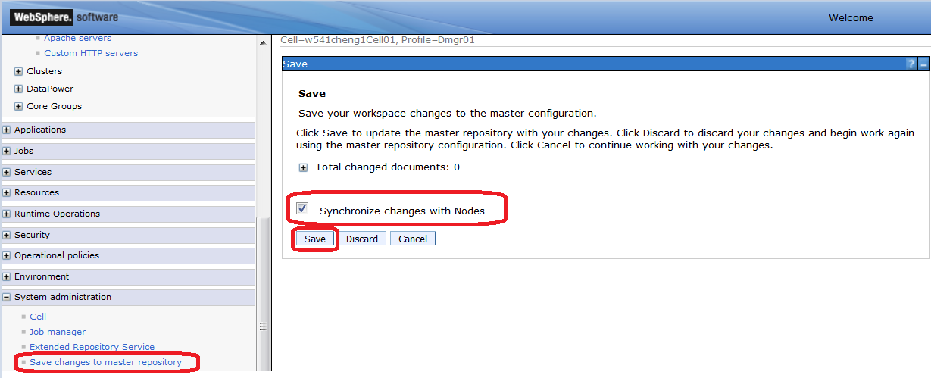

1. Restart the target server, e.g. **sampleServer1,** that has been updated the PMI configuration to “**Extended**”.
2. Click “**Current activity**” from left menu under “**Performance Viewer**” section, then click the target server, e.g. sampleServer1 on the right panel to open “**Tivoli Performance Viewer**” of the target Server.

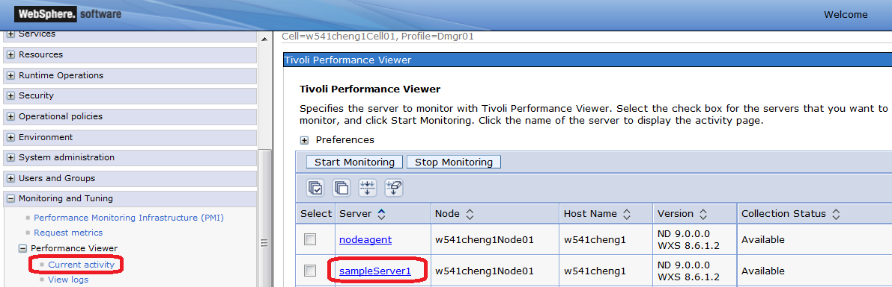

1. In the “**Tivoli Performance Viewer**” of the target Server, expand the “**Settings**” section, then click on the “**Log**” to open “**Logging Settings**”.

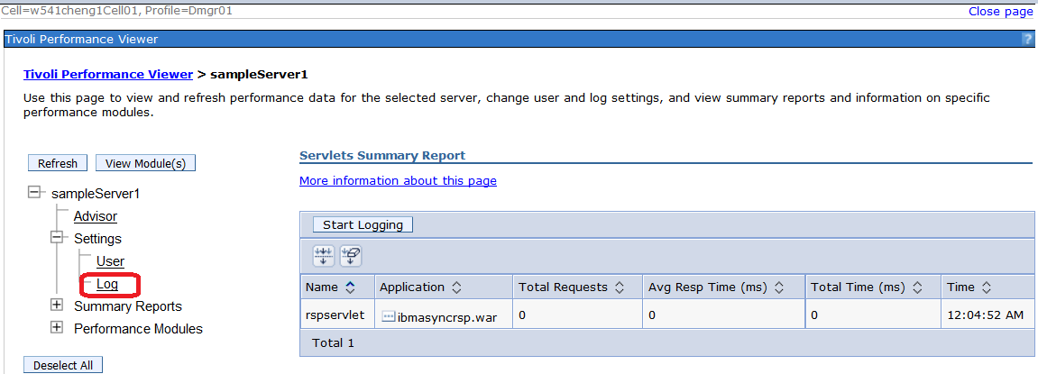

1. In the “**Logging Settings**” panel, change the setting to be as the following figure, then click “Apply” button.

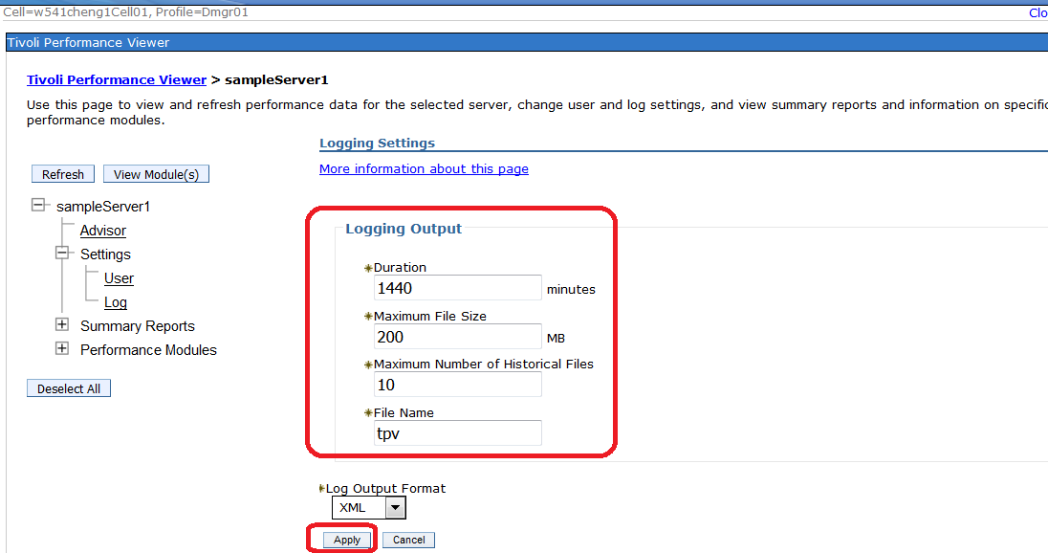

1. After clicking “Apply”, you should see the following message.

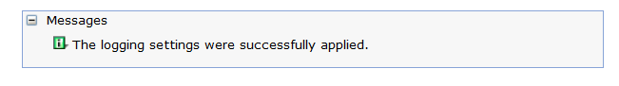

1. Click “**Current activity**” from left menu under “**Performance Viewer**” section, then click the checkbox of the target server, e.g. sampleServer1 on the right, then click on “**Start Monitoring**”.

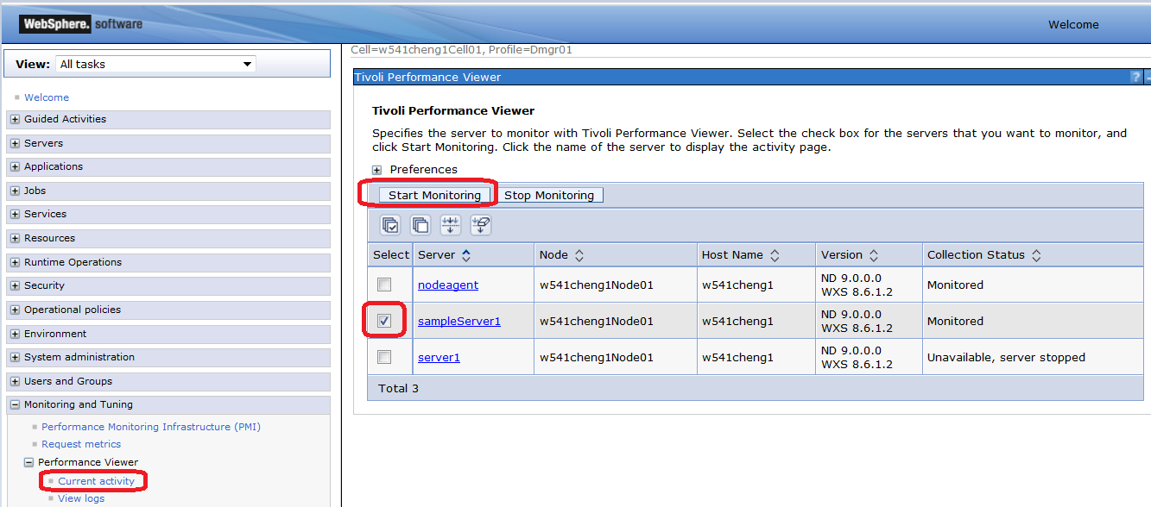

1. You should see the following message.

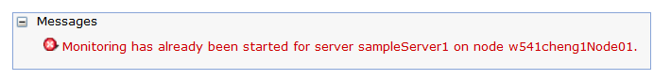

1. Click “**Current activity**” from left menu under “**Performance Viewer**” section, then click the target server, e.g. sampleServer1 on the right panel to open “**Tivoli Performance Viewer**” of the target Server.

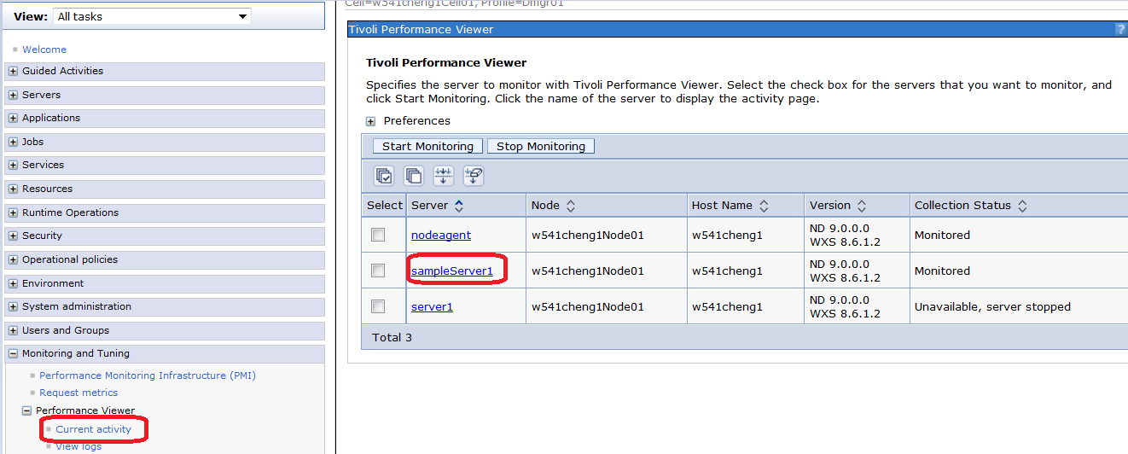

1. On the “**Tivoli Performance Viewer**” of the target Server, click “**Start Logging**” button.

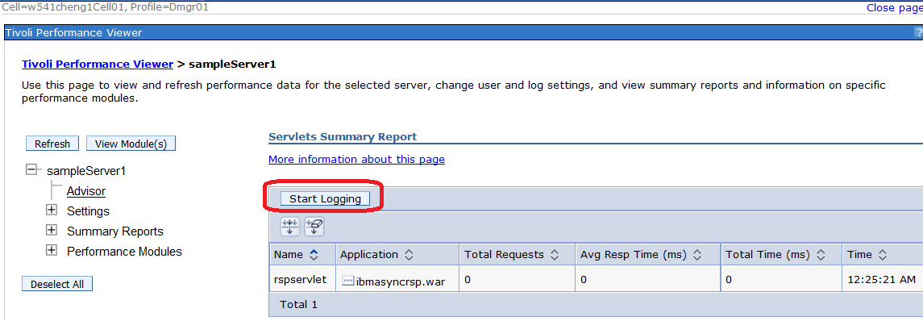

1. You should see the following message: “*Logging has started for server XXX on node YYY*.”

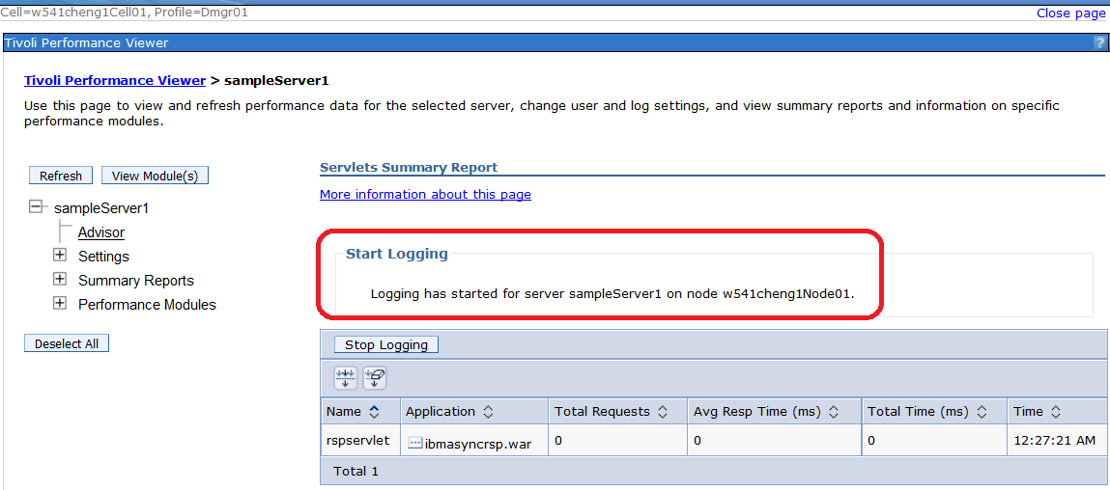

1. The TPV log file path is <WAS_INSTALL>/profiles/<PROFILE>/logs/tpv/tpv_SERVER_xxx.xml. The following illustrates the tpv file path example.

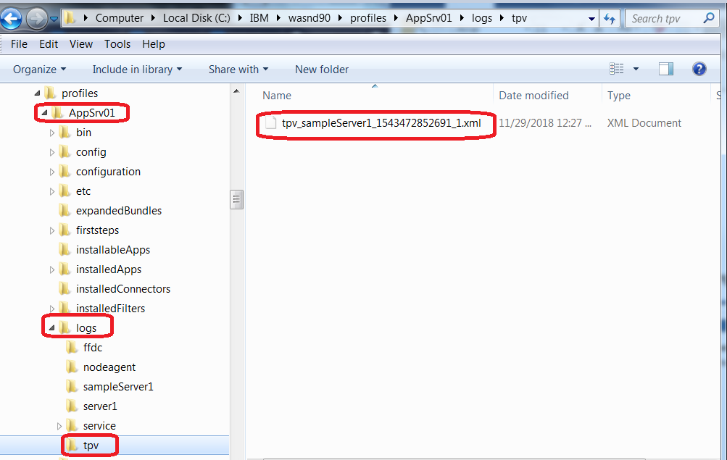

1. We want to have 24 hours of tpv data, so you should collect the tpv folder after 24 hours.
2. After 24 hours, the tpv logging should be stopped automatically because the duration of logging setting is set to 1440 minutes that is equivalent to 24 hours. You can manually stop tpv logging by clicking the “Stop Logging” button.

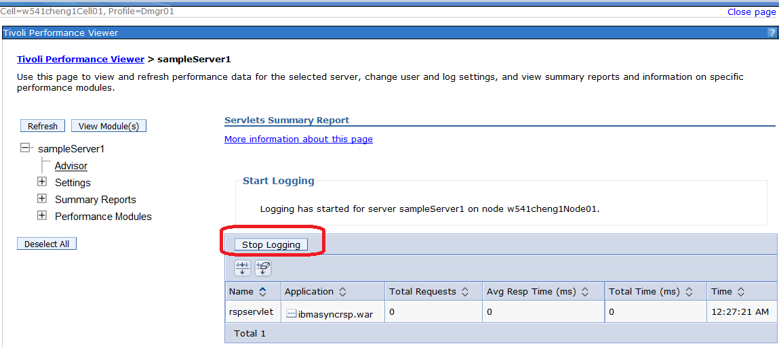

# Collecting TPV Log

The TPV log file path is <WAS_INSTALL>/profiles/<PROFILE>/logs/tpv/tpv_SERVER_xxx.xml. The following illustrates the tpv file path example. You can simply collect the “tpv” folder independently, or collect the “tpv” folder as part of collecting WAS logs directory per profile per machine.

